Snap!

In this project you will make a simple version of the card game “Snap!” in Scratch.

To have your move, you’ll take a photo of your card.

But first, you’ll need to train the computer to look at your photos and recognise the different cards in your pack.

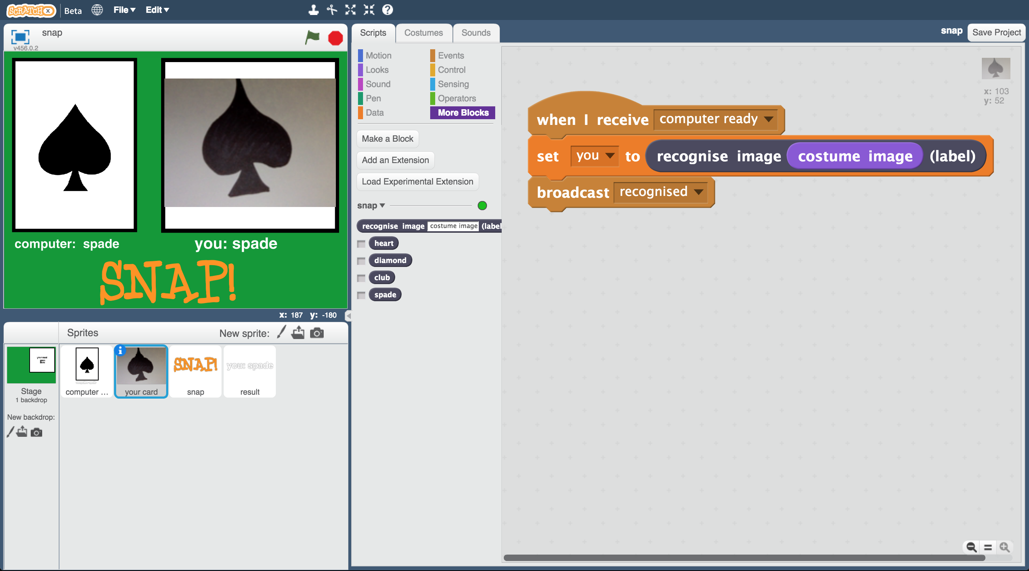

This project worksheet is licensed under a Creative Commons Attribution Non-Commercial Share-Alike License

http://creativecommons.org/licenses/by-nc-sa/4.0/

1. You’ll need four cards for this project  
   *Ask your group leader for a club, spade, heart and diamond.*
2. Go to <https://machinelearningforkids.co.uk/> in a web browser
3. Click on “**Get started**”
4. Click on “**Log In**” and type in your username and password  
   *If you don’t have a username, ask your teacher to create one.  
   If you can’t remember your username or password, ask your teacher or group leader to reset it for you.*
5. Click on “**Projects**” on the top menu bar
6. Click the **“+ Add a new project**” button.
7. Name your project “snap” and set it to learn to recognise “**images**”.   
   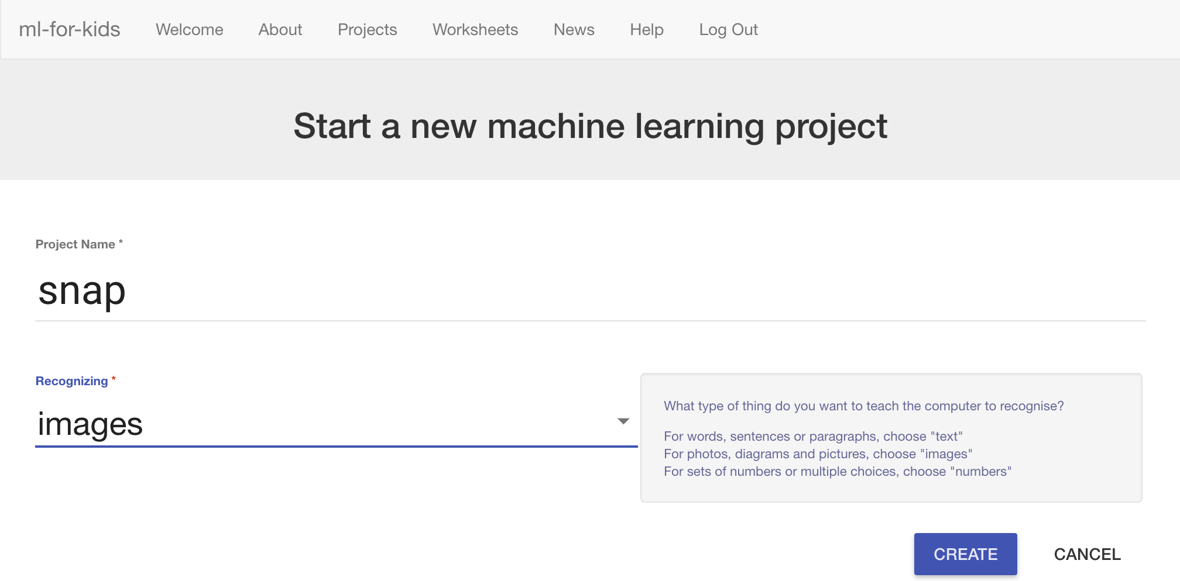
8. Click the “**Create**” button
9. You should see “snap” in the projects list. Click on it.
10. Click on “**Train**”  
    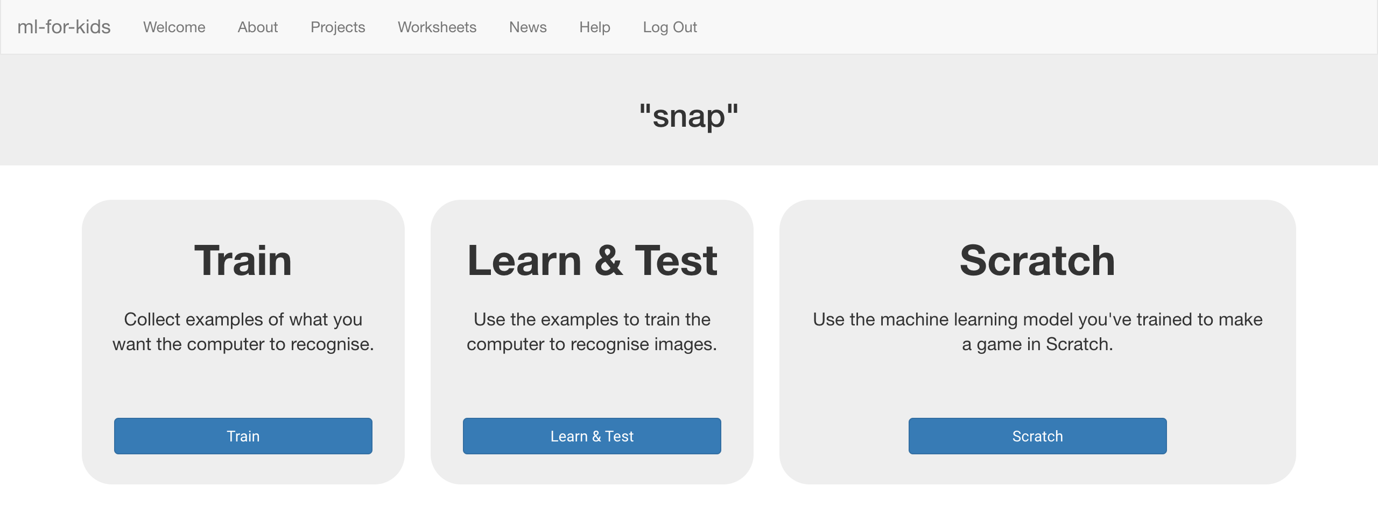
11. Click on “**+ Add new label**” and create a bucket called “heart”.  
    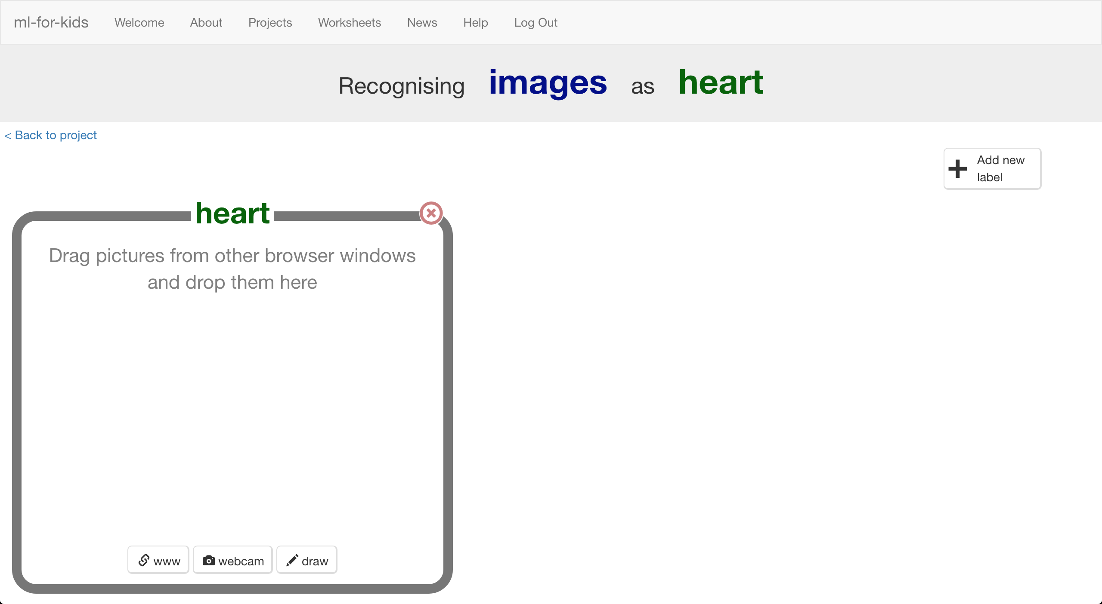
12. Click the “**webcam**” button  
    The Preview window shows the current view from your webcam.  
    *You will need to click “Approve” or “Allow” if your web browser asks permission to use your webcam.*
13. Hold the Heart card to the webcam and click “**Add**” to take a photo **
14. Repeat until you’ve taken **10 photos** of the Heart card  
    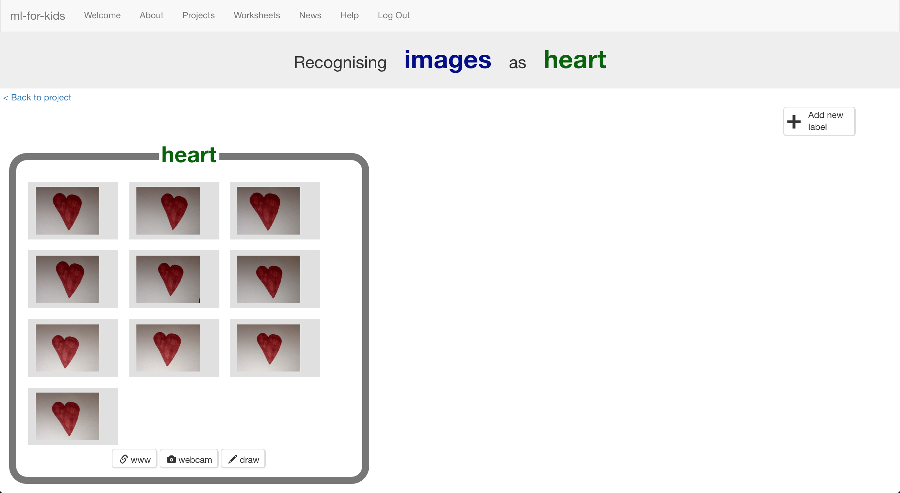
15. Click “**+ Add new label**” and create one called “diamond”
16. Use the “**webcam**” button in the “diamond” bucket to   
    take 10 photos of your Diamond card
17. Repeat for “club” and “spade”.  
    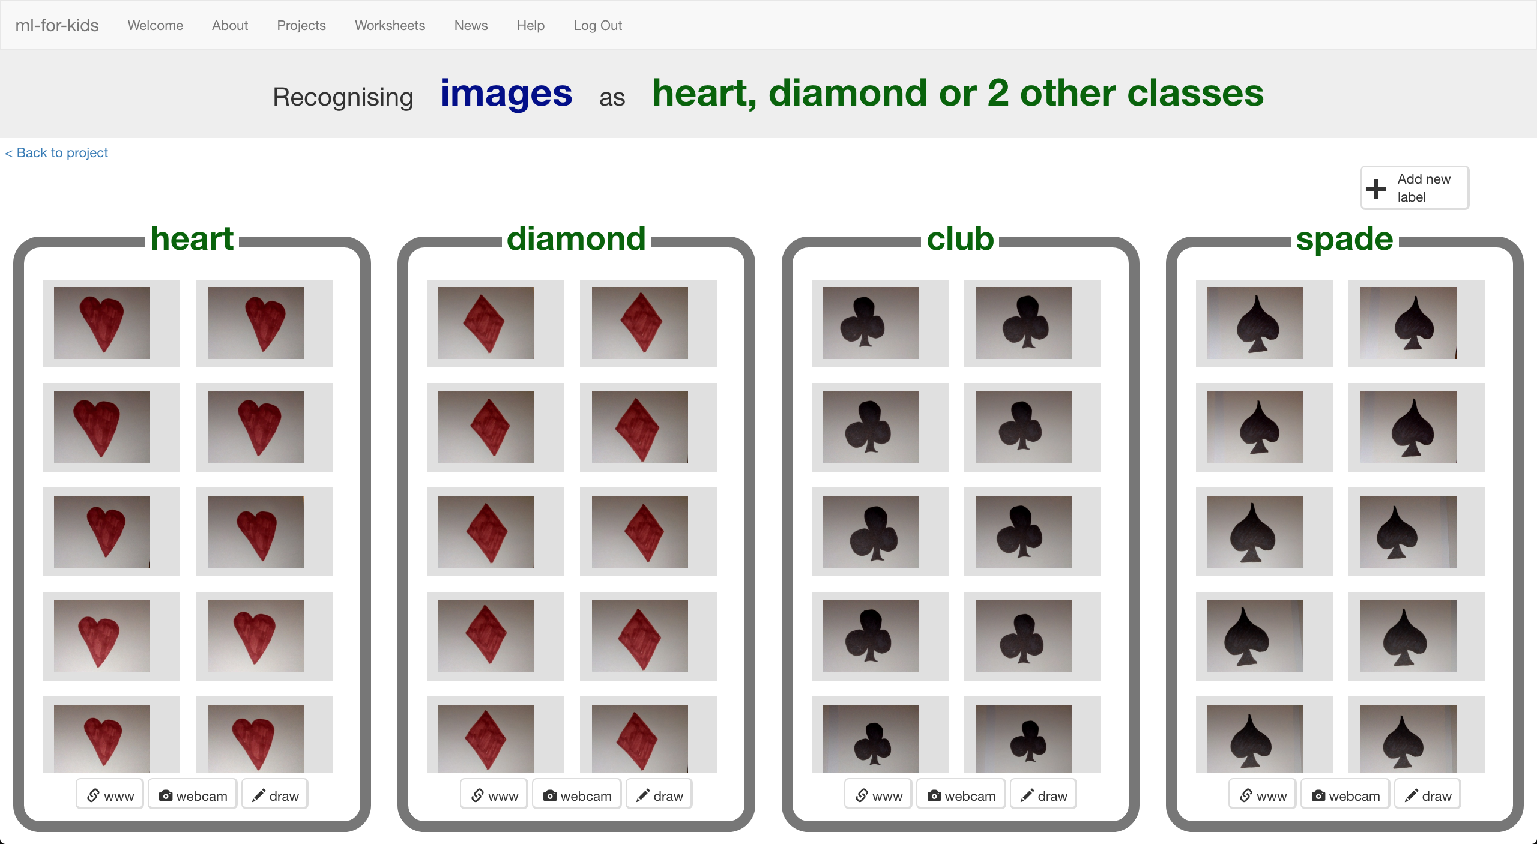
18. Click on the “**< Back to project**” link.
19. Click the “**Learn & Test**” button.
20. Click the “**Train new machine learning model**” button.   
    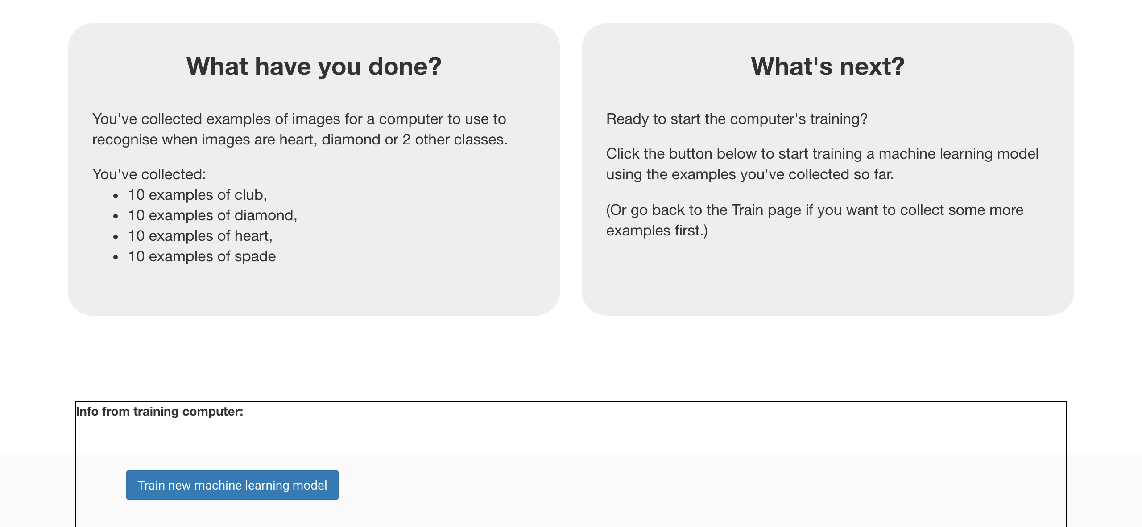
21. Wait for the training to complete. This might take a few minutes.  
    *While waiting, try to complete the machine-learning multi-choice quiz at the bottom of the page.*

**What have you done so far?**

You’ve started to train a computer to recognise cards as being heart, diamond, club or spades. You are doing it by collecting example photos. These examples are being used to train a machine learning “model”.

This is called “supervised learning” because of the way you are supervising the computer’s training.

The computer will learn from patterns in the colours and shapes from each of the photos you’ve given it. These will be used to be able to recognise new photos.

1. Click the **“< Back to project**” link, then click the “**Scratch**” button.   
   *This page has instructions on how to use the new Scratch.   
   Keep the page open if you need to check back on how to use them.*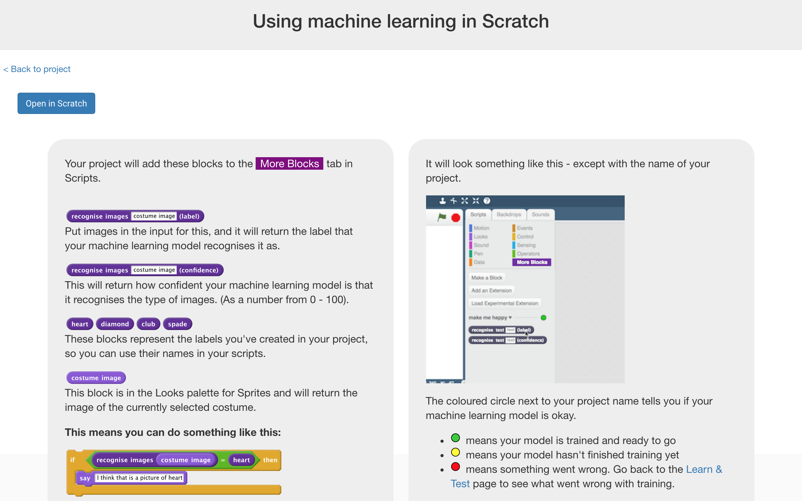

**Tips**

**More examples!**

The more examples you give it, the better the computer should get at recognising whether a card is heart, diamond, club or spades.

**Try and be even**

Try and come up with roughly the same number of examples for each shape.

If you have a lot of examples for one type, and not the other, the computer might learn that type is more likely, so you’ll affect the way that it learns to recognise photos.

1. Click the “**Open in Scratch**” button to launch the Scratch editor.   
   *You should see five new blocks in the “More blocks” section from your “snap” project.*  
   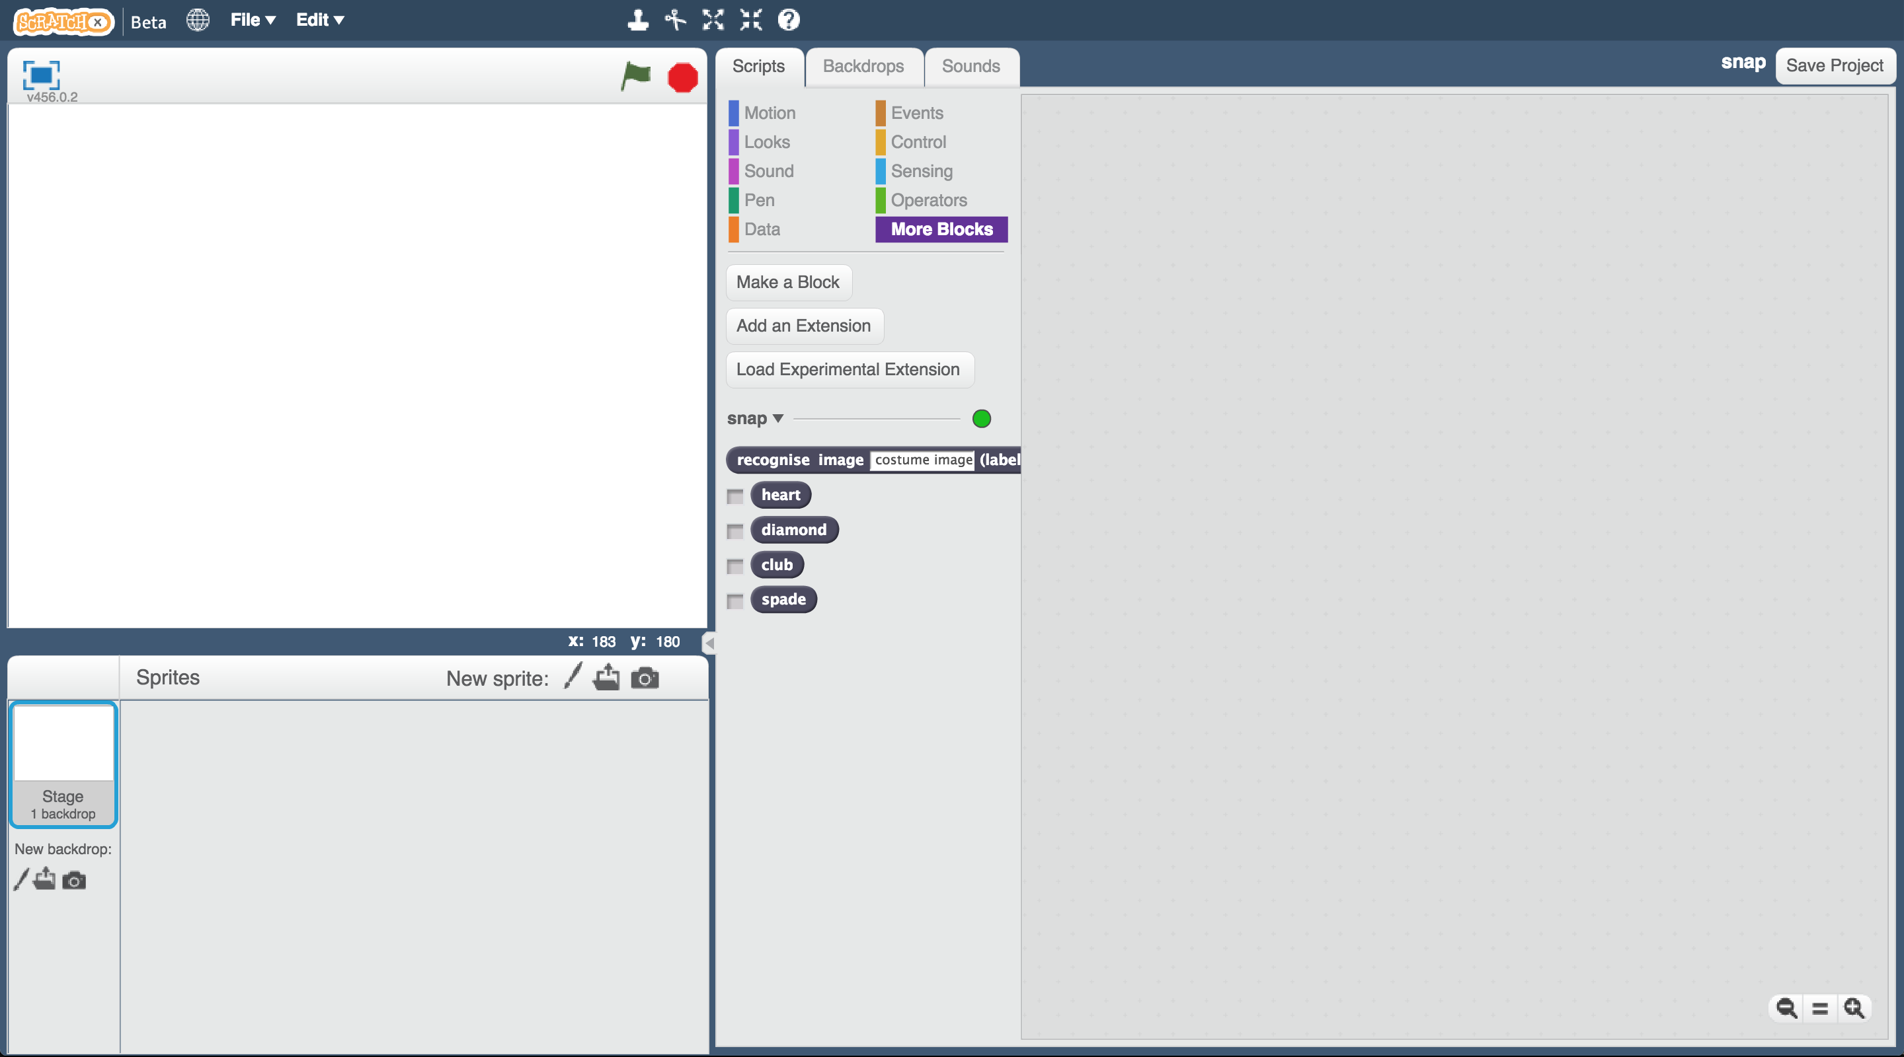

1. Open the **Snap** project template.   
   *Click* ***Project templates*** *->* ***Snap****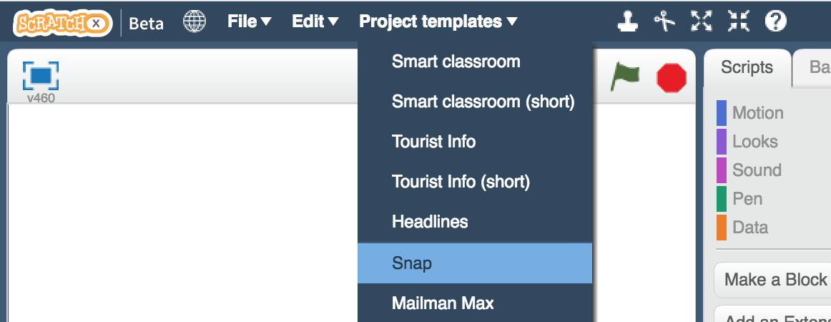*
2. Click on the “computer card” sprite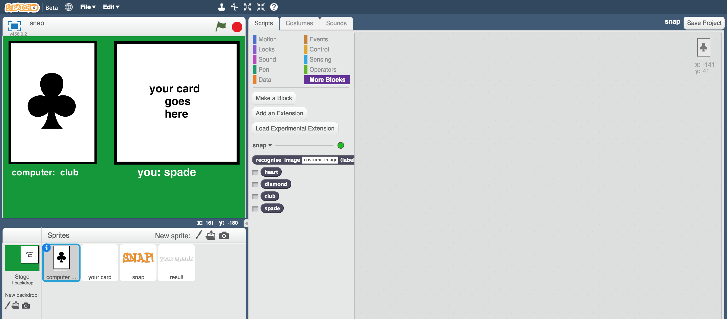
3. Create this script  
   *This script will let the computer pick a random card.*   
   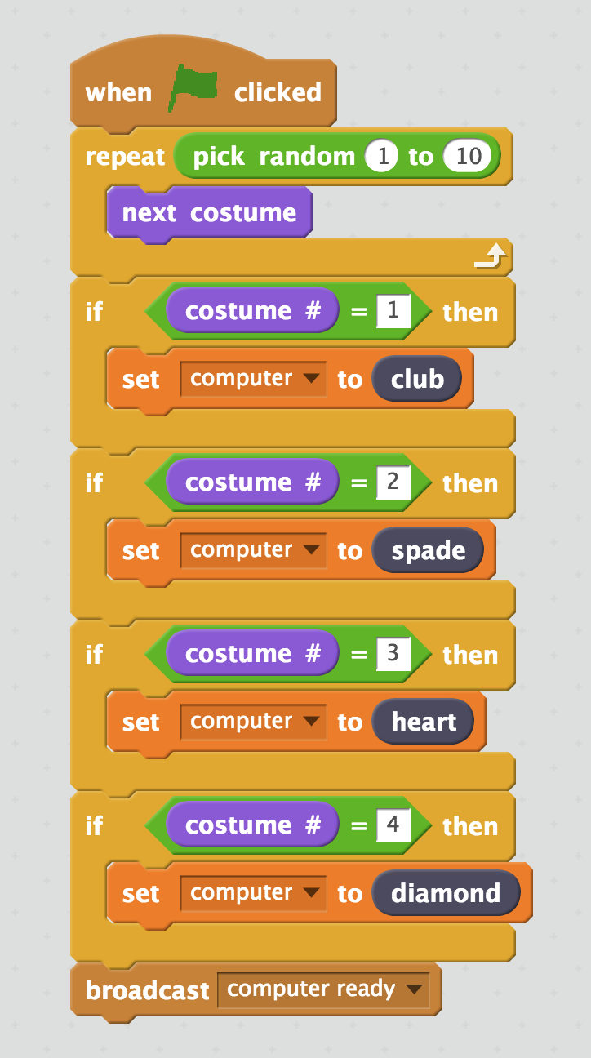
4. Click on the “your card” sprite  
   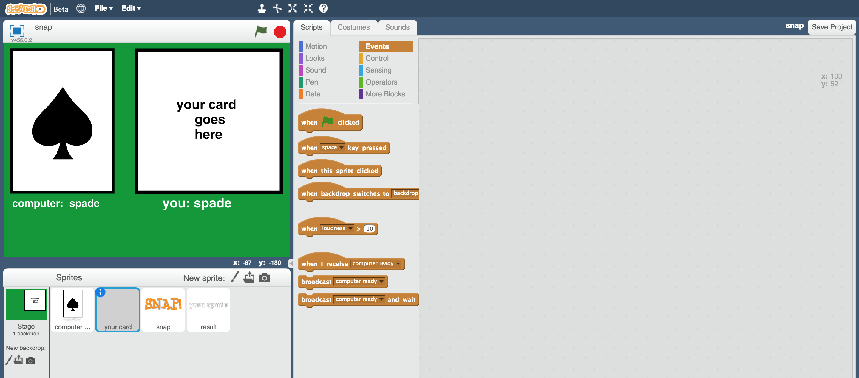
5. Create this script  
   *This script will let the computer recognise your card.*  
   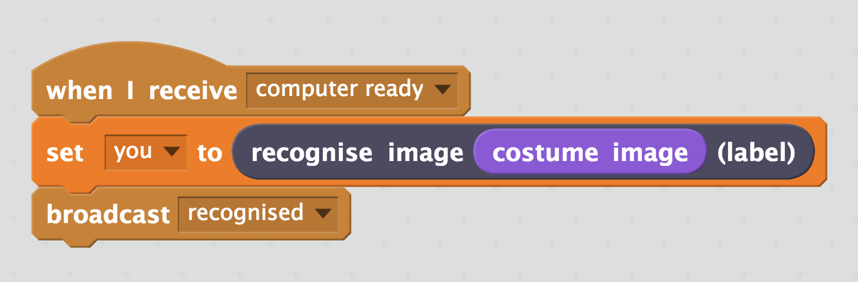
6. Click on the “snap” sprite  
   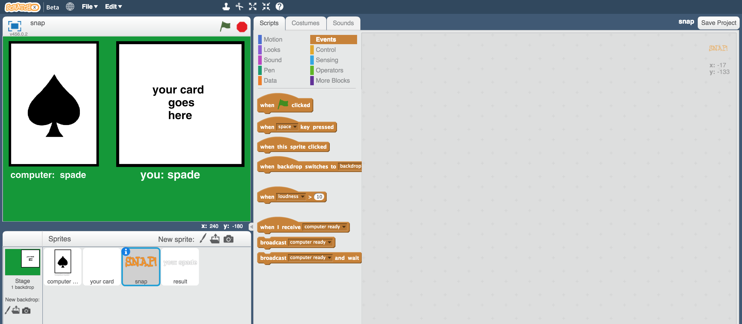
7. Create these scripts  
   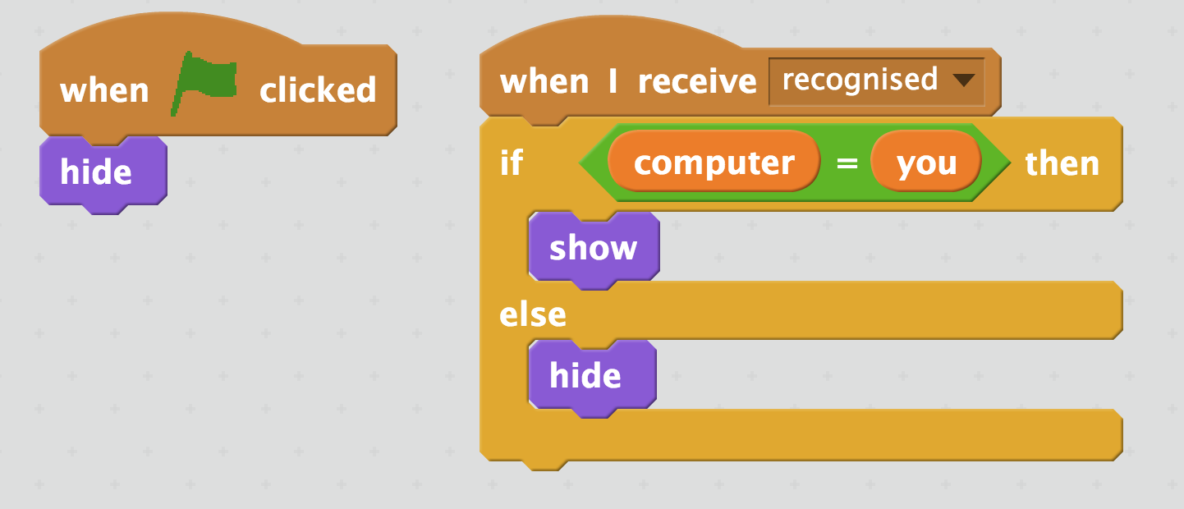
8. Click on the “result” sprite  
   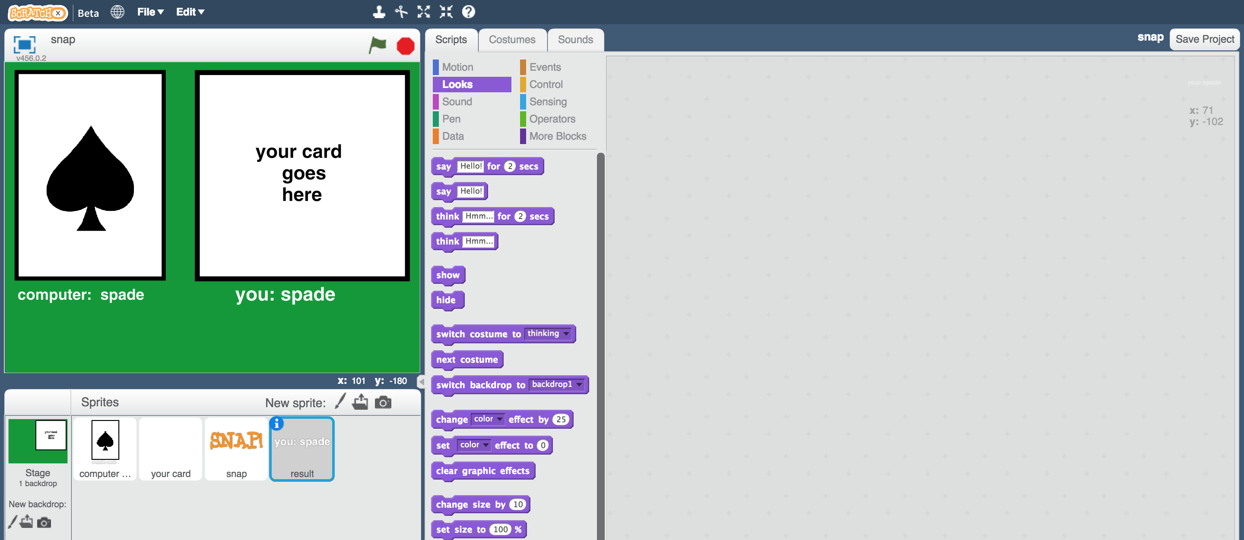
9. Create these scripts  
   *This script will display what the computer thinks your card looks like*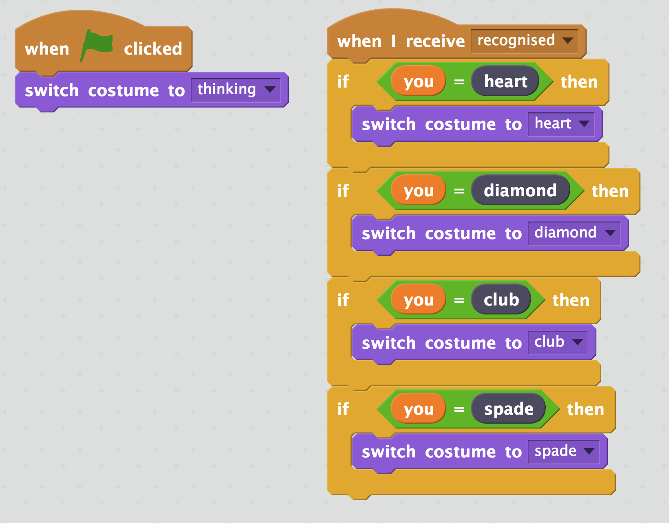
10. Save your project  
    *Click* ***File*** *->* ***Save Project***
11. Shuffle your paper cards and pick one at random
12. Click on the “your card” sprite, then the costumes tab.   
    Click on the “**New costume from camera**” button  
    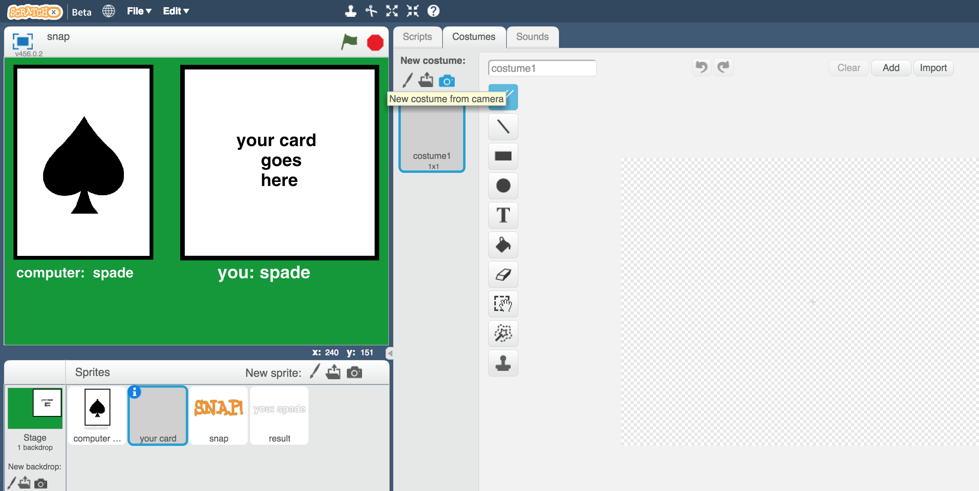
13. Use the webcam to take a photo of the card you picked  
    *Click Save when you’re ready to take the photo*  
    
14. Click the **Green Flag**

*The computer will choose a random card for its side.   
It will try to recognise your card, and if they match, it’ll display “SNAP!”   
*

**What have you done?**

You’ve made a simple card game in Scratch.

The game uses a webcam to take pictures of your card, and uses machine learning to recognise the card in the photo.

This is “image recognition” – teaching a computer to recognise images.

**Ideas and Extensions**

Now that you’ve finished, why not give one of these ideas a try?

Or come up with one of your own?

**Design your own cards**

Instead of hearts, spades, clubs and diamonds, why not make your own cards?

**Shout “snap!”**

Instead of just displaying “SNAP!” can you record yourself shouting “Snap!” and get your Scratch project to play that when the cards match?

**Make the game competitive**

Modify the game so it doesn’t display the computer’s card at first. Let it display the card at the same time it starts to recognise yours.

Who is quicker at saying “snap”? You or the computer?